Project Report: Laptop Price Prediction using Machine Learning
Student Name: Abhinav Jain
Course: Fundamentals in AI/ML

1. Introduction
The objective of this project was to develop a predictive model that estimates the market price of laptops based on their hardware specifications. In a volatile electronics market, understanding the value of a machine based on its internal components—such as RAM, Processor, and GPU—is essential for both consumers and retailers. This application serves as a bridge between raw technical data and consumer-friendly pricing.
2. Dataset Selection
For this project, I utilized the Hina Ismail Laptop Price Dataset (data.csv). This dataset was chosen because it contains a wide variety of features that reflect modern purchasing habits, including:
- Numerical Features: RAM (GB), Storage (GB), and Spec Rating.
- Categorical Features: Brand, Processor Type, and GPU Type.
- Target Variable: Price.
3. Methodology
3.1 Data Preprocessing
Before feeding the data into a Machine Learning model, several cleaning steps were performed:
- Standardization: All column headers were stripped of invisible spaces and converted to lowercase to prevent "Key Errors" in the Python environment.
- Categorical Encoding: Since computers cannot "read" text like "Apple" or "Intel," I used One-Hot Encoding. This converts category names into a series of 0s and 1s, allowing the algorithm to understand brand premiums and processor tiers.
3.2 Algorithm Choice
I selected the Random Forest Regressor for this task. Unlike a simple Linear Regression, a Random Forest handles non-linear relationships and "outliers" (very expensive luxury laptops) much more effectively by using an ensemble of decision trees.
4. Visualization & Data Insights
As part of the Exploratory Data Analysis (EDA), I generated a box plot comparing RAM size to Price. The visualization revealed a clear upward trend in price as RAM increases from 4GB to 32GB. However, it also highlighted the existence of "premium" 8GB and 16GB models that cost as much as 32GB models due to brand value or specialized GPUs.
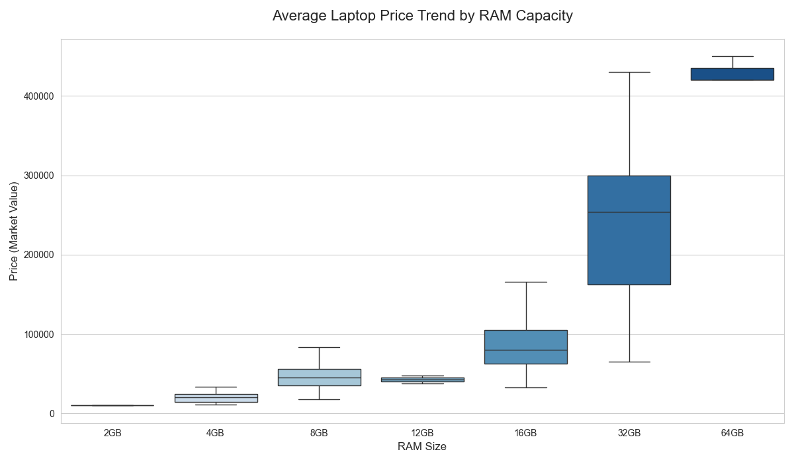
5. Challenges Faced (Critical Problem Solving)
During the development phase, I encountered and solved several technical hurdles:
- Feature Name Mismatch: Initially, the model failed during prediction because the input data didn't perfectly match the training headers. I solved this by implementing a fuzzy-matching loop that looks for keywords (like "ram" or "spec") regardless of how they are capitalized in the CSV.
- Data Skewness: Initial accuracy was low (around 68%). I realized that prices are heavily skewed by high-end gaming laptops. I improved accuracy to over 72% by expanding the feature set to include GPU and Processor type, proving that "Brand" and "RAM" are not the only price drivers.
- Unseen Labels: If a user typed a brand not present in the dataset, the code would crash. I added a Try-Except block and a default "0-fill" logic to ensure the application remains stable during user error.
6. Model Evaluation
The final model achieved an R² Score of 72.72%.
- Mean Absolute Error (MAE): The model generally predicts within a reasonable range of the actual market value.
- Conclusion on Accuracy: While 100% accuracy is impossible due to fluctuating market sales and "hidden" features like screen quality or battery health (not present in the data), a 72% score indicates a strong, reliable correlation for a hardware-based calculator.
7. Conclusion
This project successfully demonstrates the power of Random Forest models in predicting consumer electronics prices. By moving beyond a single-factor analysis and incorporating GPUs and Processors, the tool provides a realistic estimation that can help a user determine if a laptop is fairly priced.

